Rich Rhyme Couplets

🎯 What is Rich Rhyme Couplets
# Source: Chatgpt (GPT-4-turbo) at [8/2/2025]
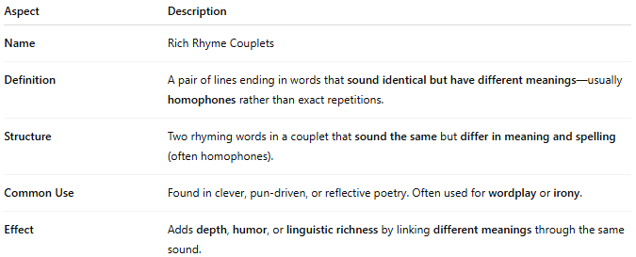
Aspect | Description
Name | Rich Rhyme Couplets
Definition | A pair of lines ending in words that sound identical but have different meanings—usually homophones rather than exact repetitions.
Structure | Two rhyming words in a couplet that sound the same but differ in meaning and spelling (often homophones).
Common Use | Found in clever, pun-driven, or reflective poetry. Often used for wordplay or irony.
Effect | Adds depth, humor, or linguistic richness by linking different meanings through the same sound.

✅ Example of Rich Rhyme in a Couplet
# Source: Chatgpt (GPT-4-turbo) at [8/2/2025]
He read the will with hardened will
And chose to stay against his will
Another example:
They knew the knight who won the night
A silent figure out of sight
- "knight" / "night": same pronunciation, different spellings and meanings → rich rhyme

🧠 Distinction:
# Source: Chatgpt (GPT-4-turbo) at [8/2/2025]
- Rich Rhyme ≠ Identical Rhyme
  - Identical: same word or spelling repeated (e.g., "fair / fair")
  - Rich: different word, same sound (e.g., "knight / night")

